Practical 4
Aim
To access the AWS Billing Dashboard, view service costs, create a budget, configure billing alerts, and analyze AWS usage patterns using AWS Cost Explorer for effective cost optimization.
Requirements
- An active AWS account
- Internet connection
- Web browser
- AWS Management Console access
Procedure
1. Sign in to AWS Management Console
- Open the AWS Management Console.
- Sign in using the AWS account credentials.
- Ensure the selected AWS Region is Asia Pacific (Mumbai) (ap-south-1).

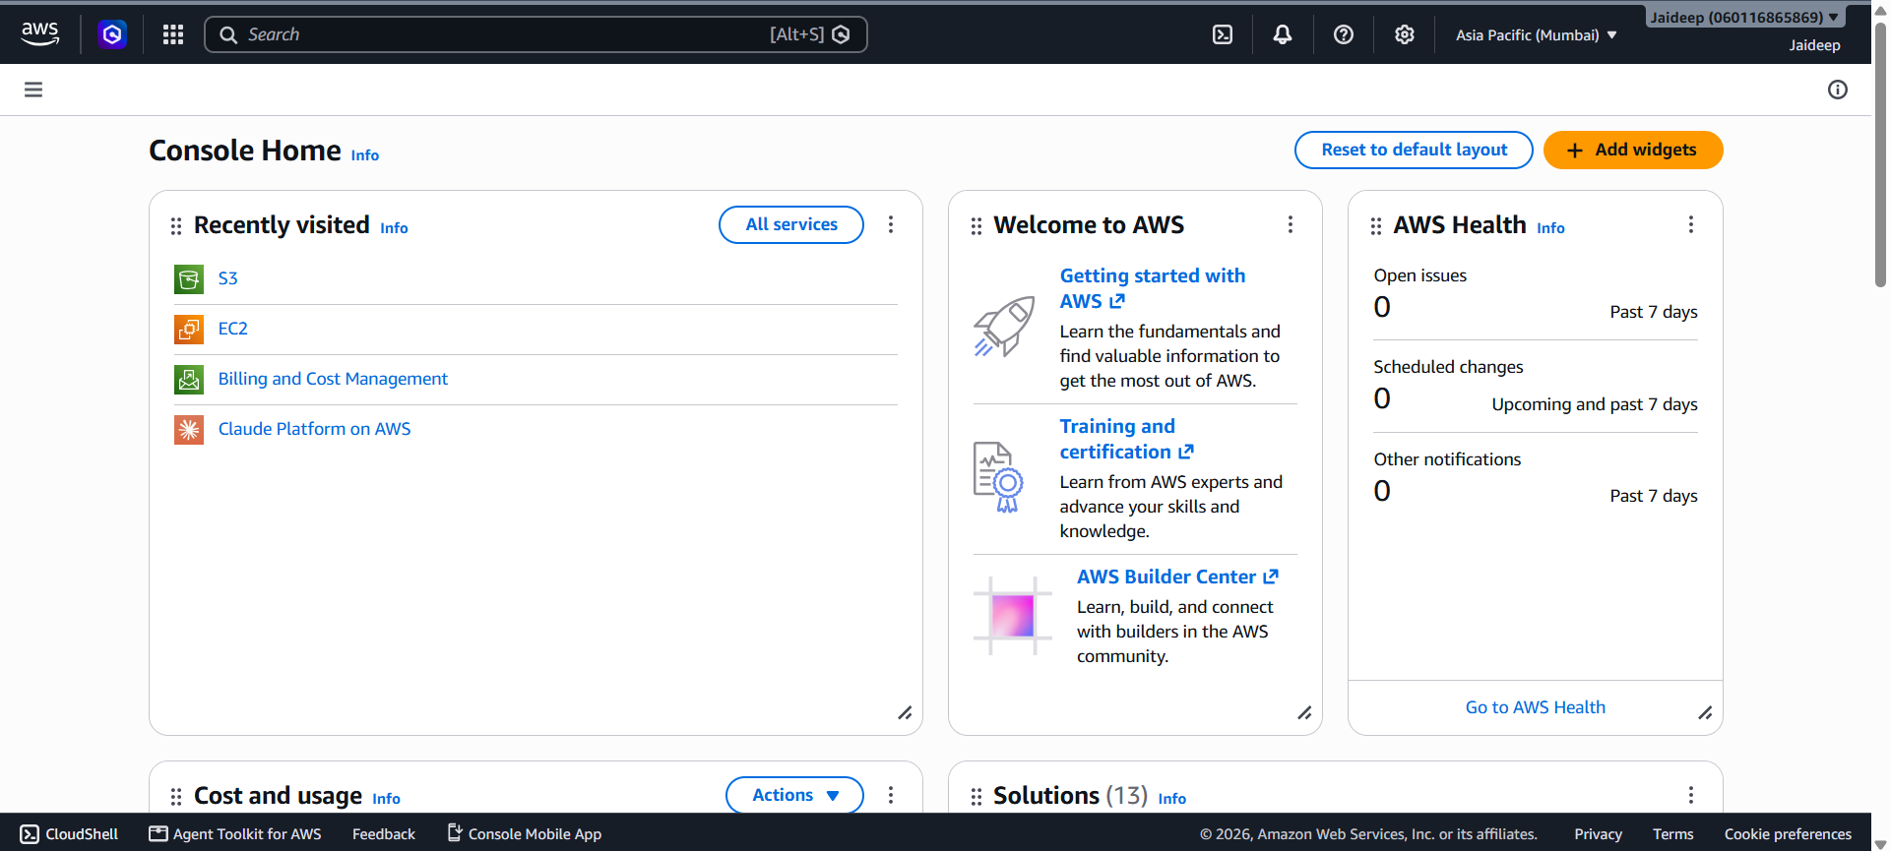
2. Access the Billing Dashboard
- In the AWS Management Console, search for Billing and Cost Management.
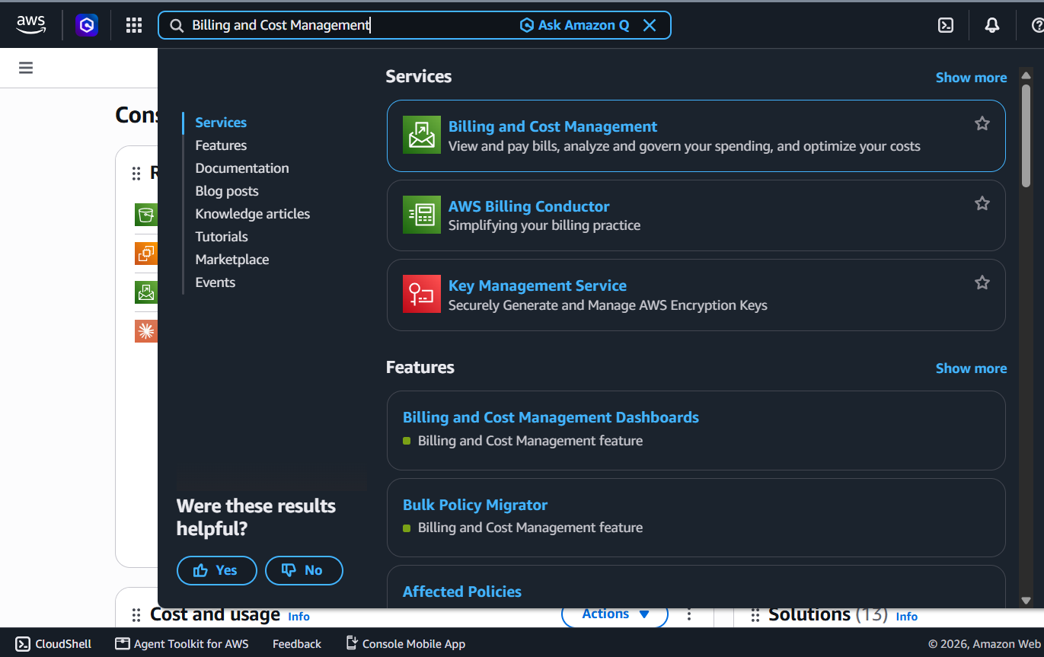
- Open the Billing and Cost Management dashboard.
- Review the available billing information, including:
  - Current charges
  - Previous charges
  - Cost by AWS service
  - Free Tier usage, where applicable
  - Billing and payment information

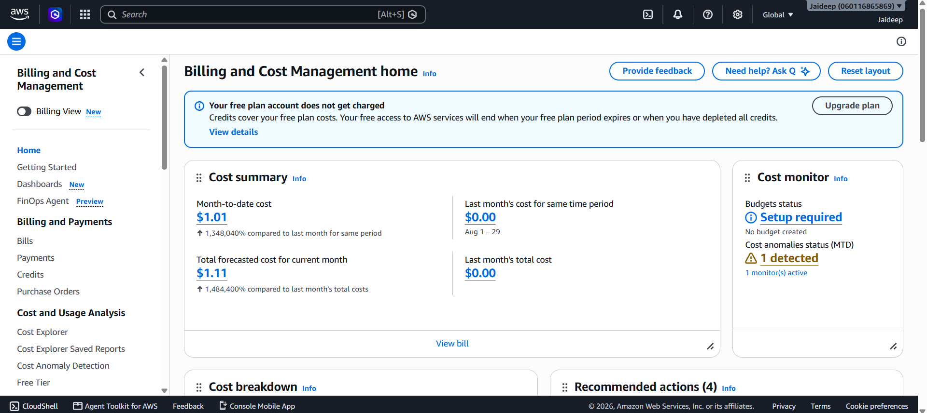
3. View Service Costs
- Open Bills from the Billing and Cost Management section.
- Select the required billing period.

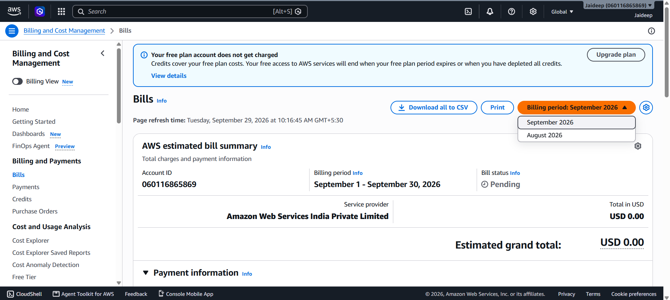
- Expand the services listed under the bill.
- Review the charges associated with individual AWS services.
- Identify services contributing to the overall AWS expenditure.
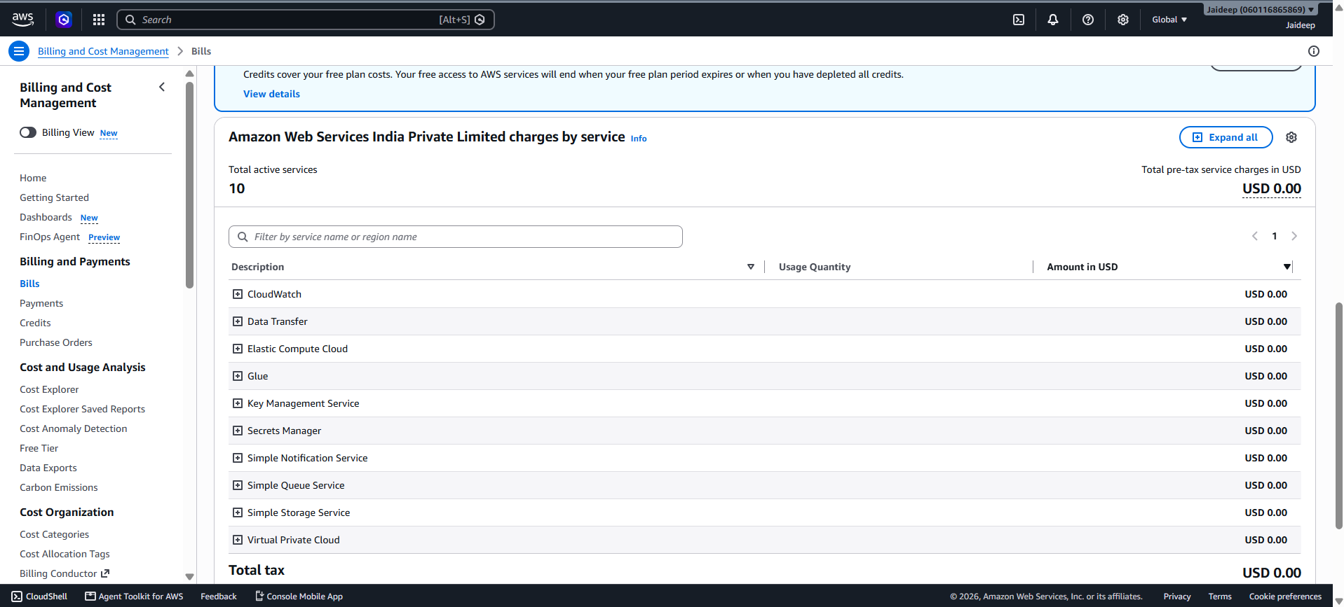
4. Create an AWS Budget and Configure Billing Alerts
Step 1 – Choose Budget Type
- Open Budgets from the Billing and Cost Management console.
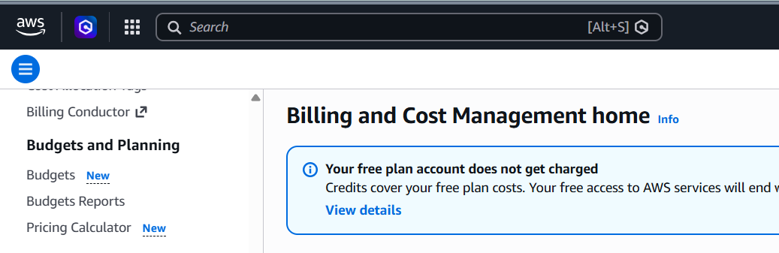
- Select Create budget.

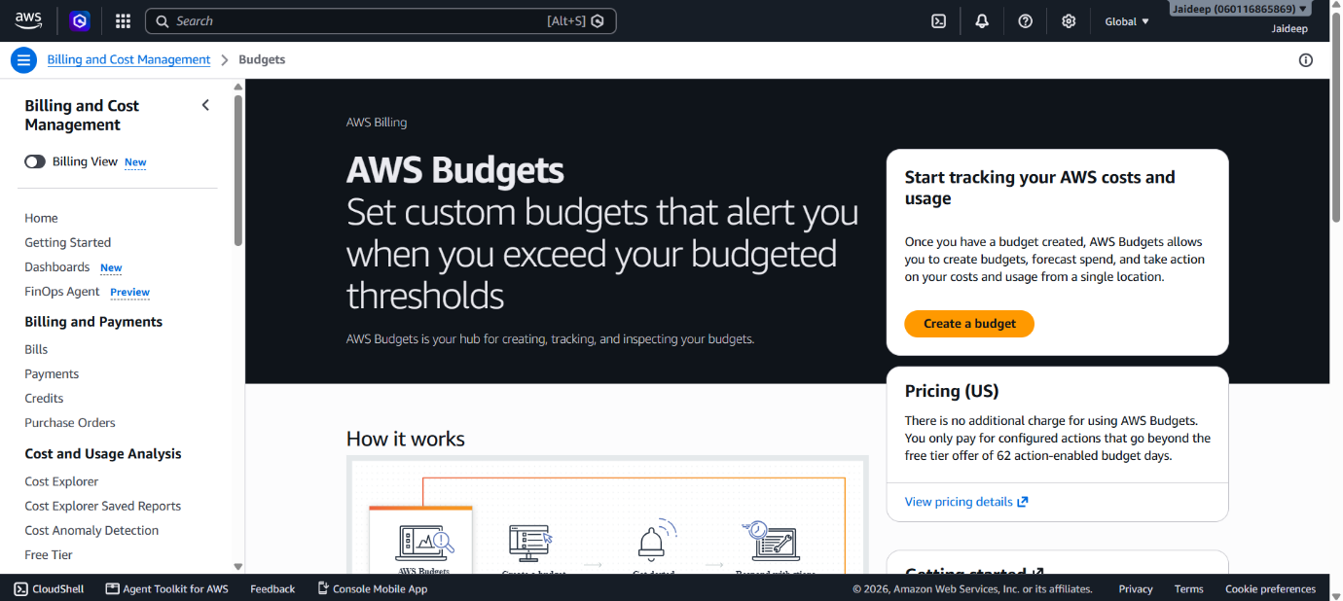
- Select Customize (advanced) under Budget setup.

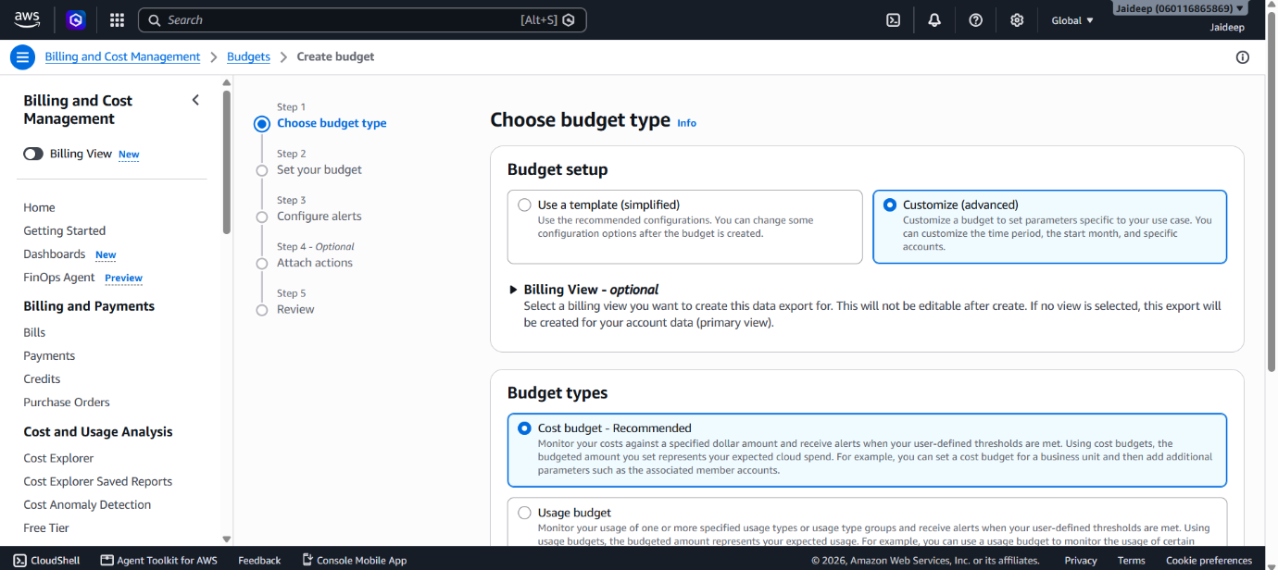
- Select Cost budget as the budget type.
- Click Next.

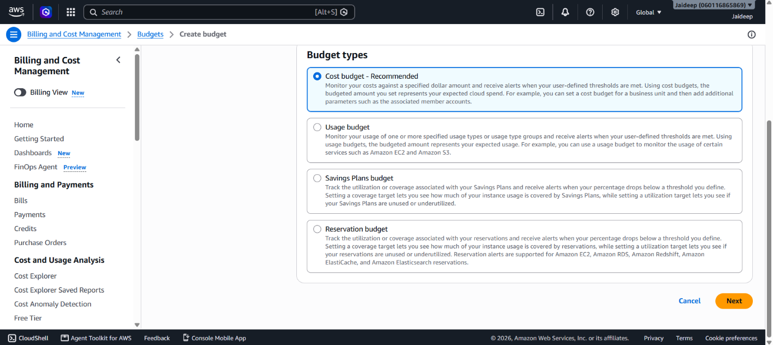
Step 2 – Set Your Budget
- Enter a suitable Budget name.
- Under Set budget amount, select the required:
  - Period, such as Monthly
  - Budget renewal type, such as Recurring budget
  - Start month
  - Budgeting method, such as Fixed
- Enter the required budgeted amount.

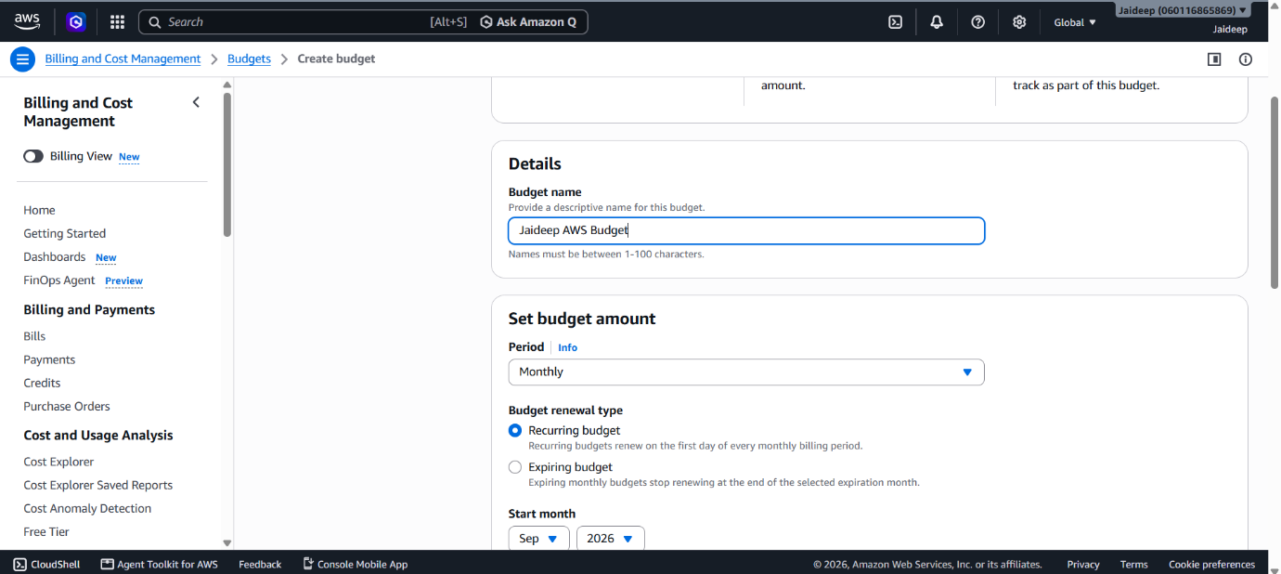
- Under Budget scope, select All AWS services (Recommended) to monitor overall AWS expenditure.
- Keep Aggregate costs by as Unblended costs.
- Leave Tags optional.
- Click Next.

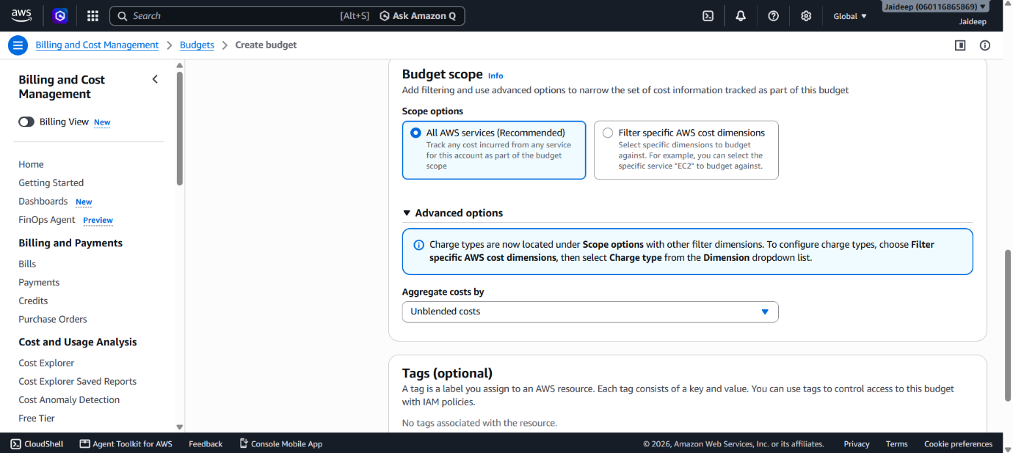
Step 3 – Configure Alerts
- Select Add an alert threshold.
- Specify the required threshold percentage of the budgeted amount. (80%)
- Select the trigger as Actual.
- Enter the email address for receiving notifications.
- Click Next.

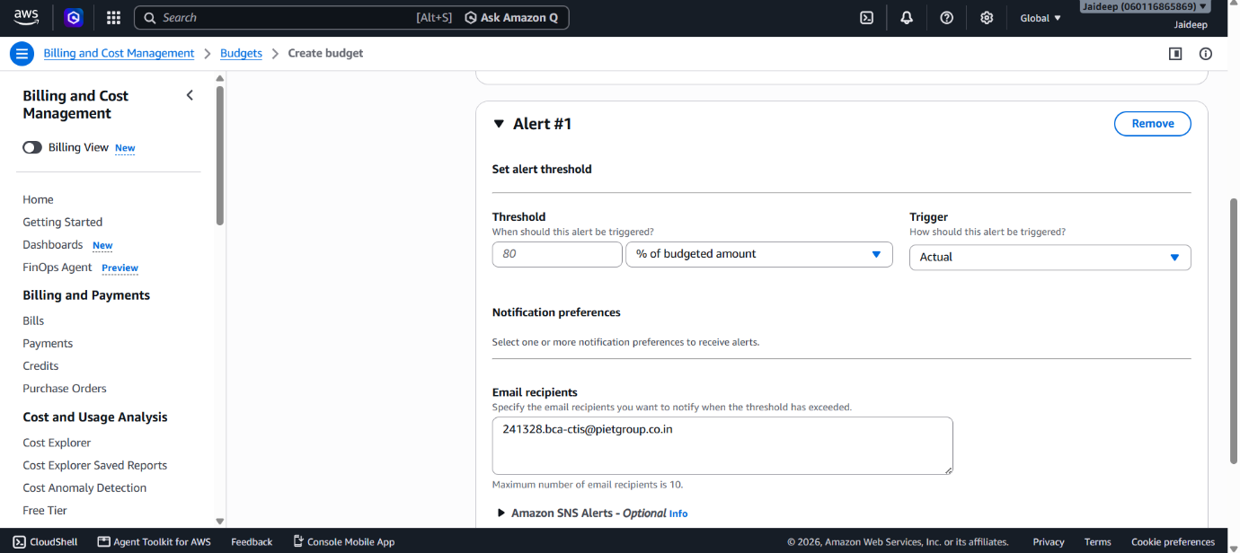
Step 4 – Attach Actions (Optional)
- Review the configured alert.
- Budget actions may be attached to automatically perform supported cost-management actions when an alert threshold is exceeded.
- If no automated action is required, leave this section unchanged.
- Click Next.

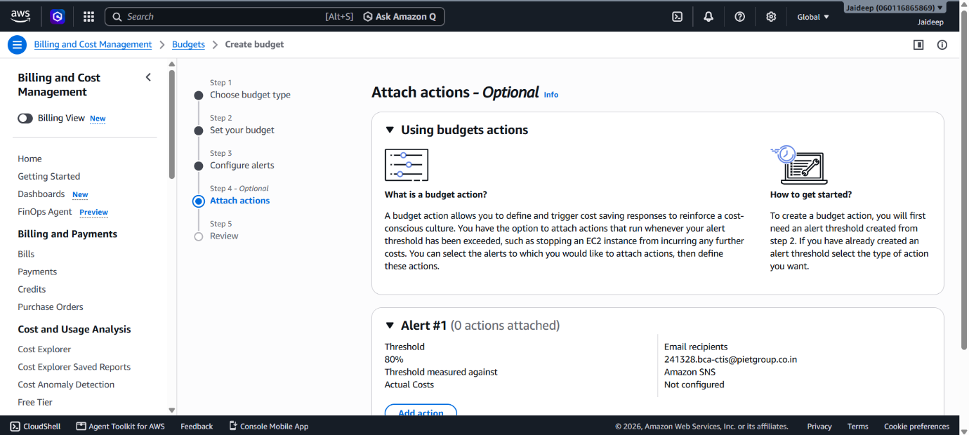
Step 5 – Review
- Review the complete budget configuration.
- Verify the budget type, amount, period, alert threshold, and notification settings.

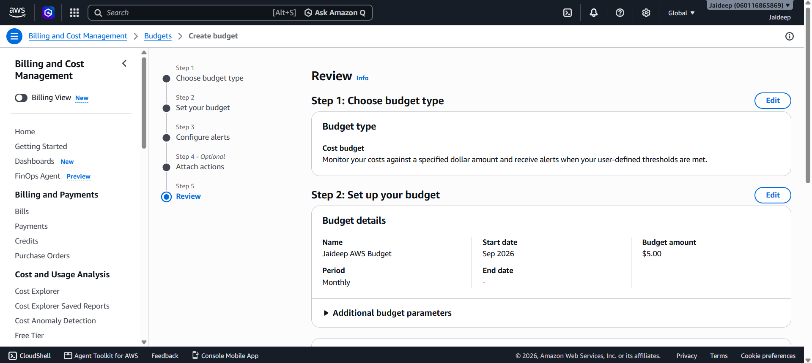
- Click Create budget to create the budget.
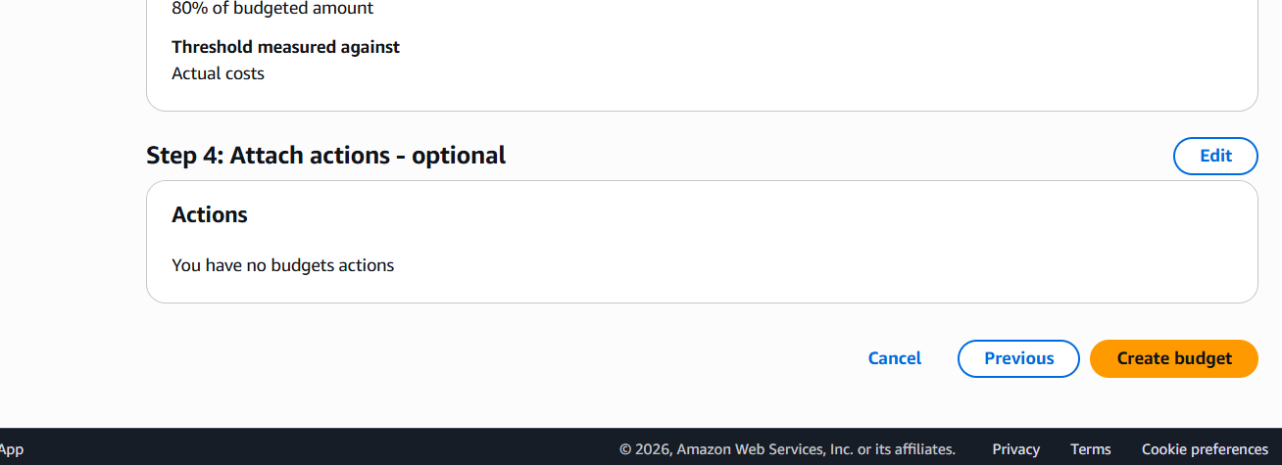
5. Analyze Usage Patterns Using AWS Cost Explorer
- Open Cost Explorer from Billing and Cost Management → Cost and Usage Analysis.
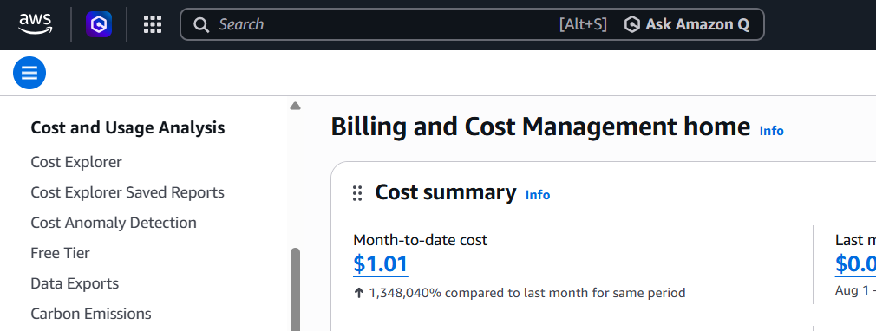
- In Report parameters, select the required Date Range for the analysis.
- Set Granularity to Monthly to observe cost trends over time.
- Under Group by, select Dimension → Service.
- Keep Filters empty when analyzing overall AWS expenditure, unless analysis of a specific service, region, or other dimension is required.

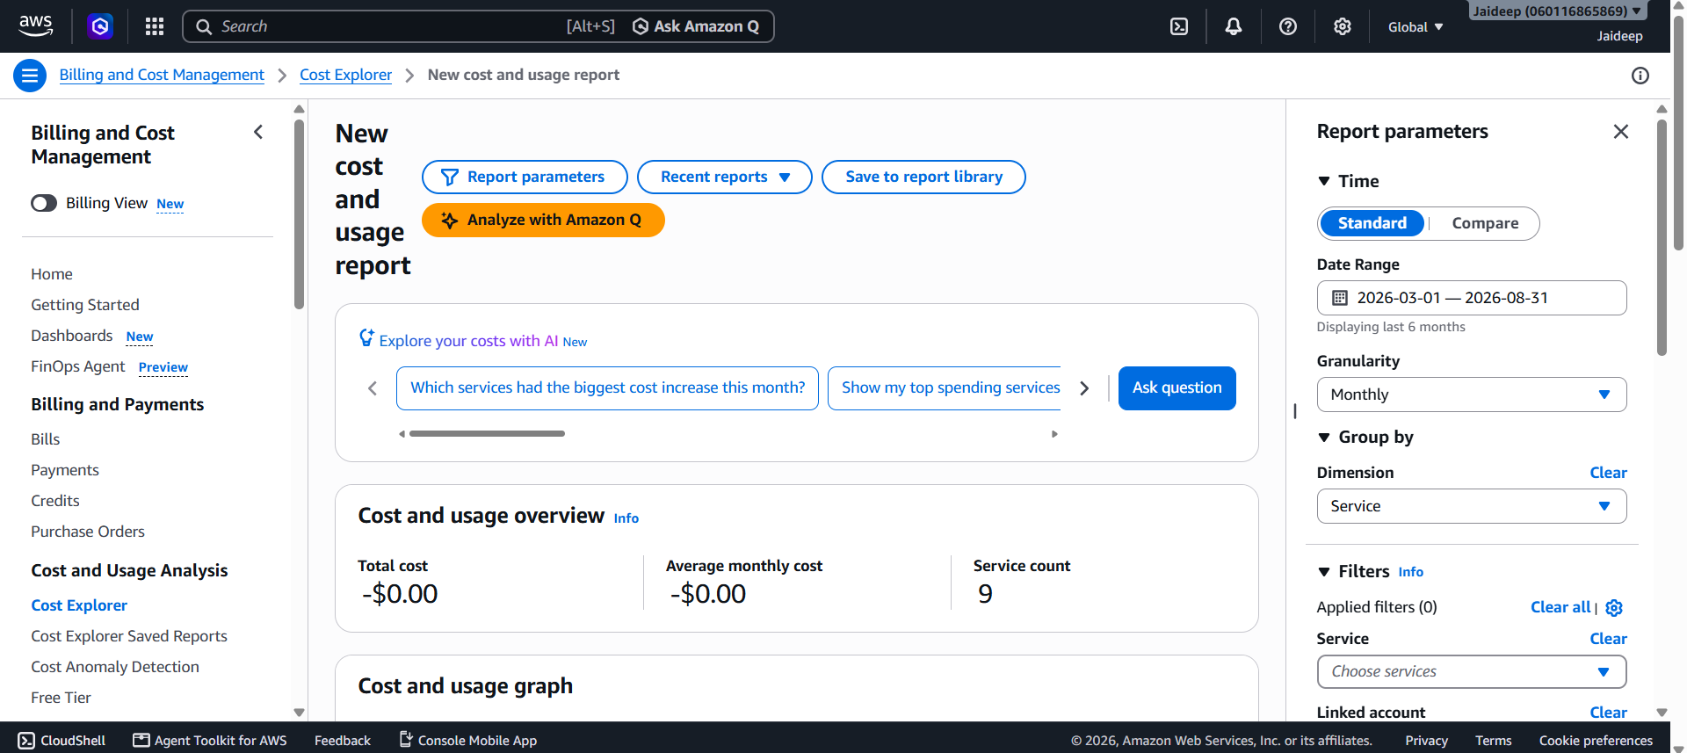
- Under Advanced options, keep Aggregate costs by → Unblended costs.
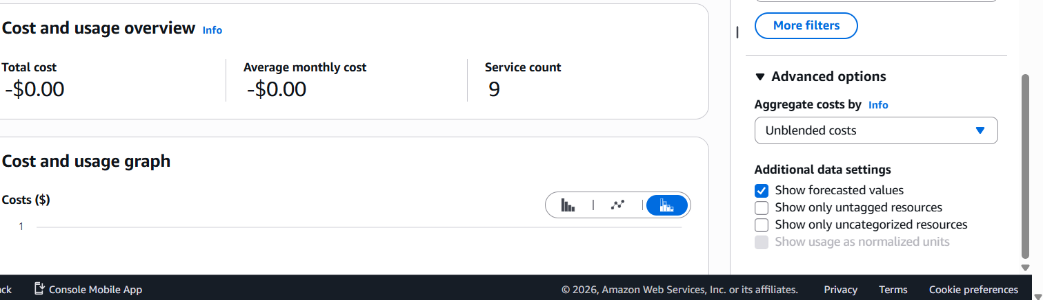
- Review the Cost and usage graph to observe changes in expenditure over the selected period.

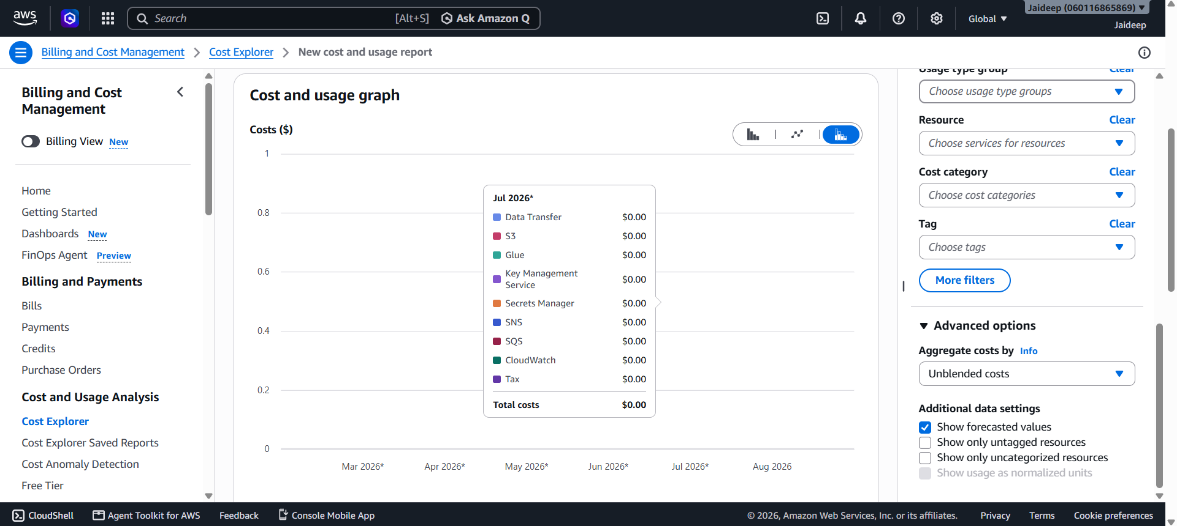
- Review the Cost and usage breakdown table to compare costs across individual AWS services.

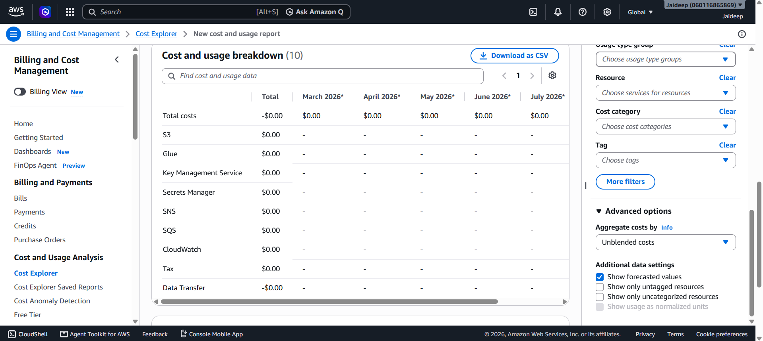
- Identify services with non-zero or relatively higher costs and observe how their costs change between months.
- Use these observations to identify spending patterns and potential areas for cost optimization.

6. Cost Optimization
After analyzing Cost Explorer:
- Identify services with unnecessary, unexpected, or increasing costs.
- Review the corresponding resource usage.
- Stop or remove resources that are no longer required, where appropriate.
- Review resource configurations and usage patterns for opportunities to reduce costs.
- Continue monitoring expenditure using Cost Explorer and AWS Budgets.
- Use billing alerts to detect future increases in expenditure.
Observation
AWS Billing Feature | Observation
Selected Region | Asia Pacific (Mumbai) — ap-south-1
Billing Dashboard | Used to view overall billing information
Bills | Used to examine service-wise charges
AWS Budgets | Used to establish a spending limit
Billing Alerts | Used to receive notifications when spending reaches a defined threshold
Cost Explorer | Used to analyze AWS cost and usage patterns

Result
The AWS Billing and Cost Management Dashboard was accessed successfully. Service costs were reviewed, an AWS Cost Budget and billing alert were configured, and AWS Cost Explorer was used to analyze service-wise cost and usage patterns. The analysis can be used to identify unnecessary expenditure and support AWS cost optimization.

